SIMATS ENGINEERING

ASSESSMENT TOOL 2

COURSE NAME: COMPUTER NETWORKS COURSE CODE: CSA0706

COURSE OUTCOME COVERED
CO5: Measure network performance using key metrics with simulation tools.
(BL4,BL5)

Assessment Tool Weightage: 30%

Annexure A

Pseudocode Writing Task (Algorithm Design)

Code of Conduct:

I RUCHITA.S (192572081) certify that this submission is my original work and that I have adhered to the guidelines specified for this assessment.
I understand that any violation of academic integrity rules will result in disciplinary action.

Signature of the student:

RUCHITA.S
Annexure A

Pseudocode Writing Task (Algorithm Design)
- In a network simulation using Cisco Packet Tracer, a student records total data received as 8000 bits in 4 seconds and observes that 200 packets were sent while 180 packets were received. Write a pseudocode algorithm to calculate the network throughput in bits per second and the packet loss percentage based on the given values. The algorithm should include validation to ensure that time and total packets sent are not zero to avoid errors. It should display both the throughput and packet loss results clearly. Add logic to classify the network as Efficient if throughput is greater than 1500 bps and packet loss is less than 10%, otherwise classify it as Inefficient. Finally, ensure the algorithm outputs a complete summary of the network performance based on the calculated metrics.
SOLUTION:

Given Data
- Total data received = 8000 bits
- Time = 4 seconds
- Packets sent = 200
- Packets received = 180
- Efficient condition:
  - Throughput > 1500 bps
  - Packet loss < 10%

Formula
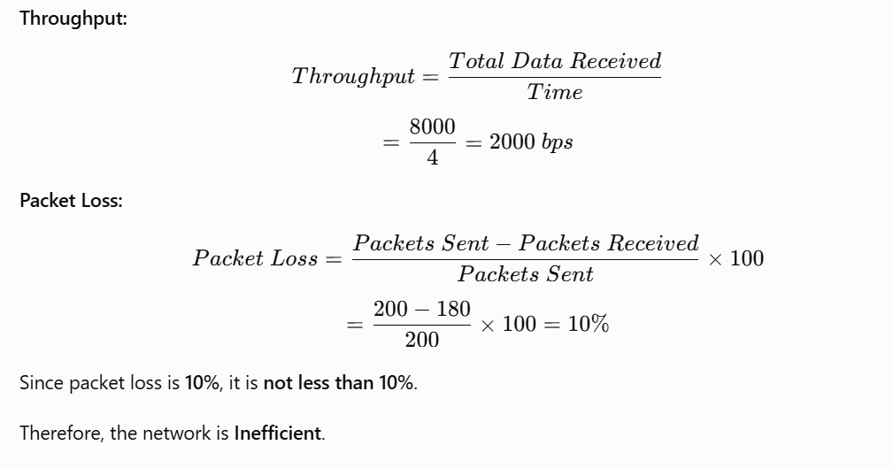

Pseudocode

BEGIN

INPUT totalDataReceived
INPUT time
INPUT packetsSent
INPUT packetsReceived

IF time = 0 THEN
DISPLAY "Error: Time cannot be zero"
STOP
END IF

IF packetsSent = 0 THEN
DISPLAY "Error: Total packets sent cannot be zero"
STOP
END IF

throughput ← totalDataReceived / time

lostPackets ← packetsSent - packetsReceived

packetLoss ← (lostPackets / packetsSent) × 100

DISPLAY "Network Throughput: ", throughput, " bps"
DISPLAY "Packet Loss: ", packetLoss, "%"

IF throughput > 1500 AND packetLoss < 10 THEN
classification ← "Efficient"
ELSE
classification ← "Inefficient"
END IF

DISPLAY "Network Classification: ", classification

DISPLAY "----- Network Performance Summary -----"
DISPLAY "Throughput = ", throughput, " bps"
DISPLAY "Packet Loss = ", packetLoss, "%"
DISPLAY "Performance = ", classification

END

Expected Output

Network Throughput: 2000 bps
Packet Loss: 10%
Network Classification: Inefficient

----- Network Performance Summary -----
Throughput = 2000 bps
Packet Loss = 10%
Performance = Inefficient
The question specifically requires validation for zero time and zero packets sent, calculation of both metrics, classification, and a final performance summary.

- An organization has multiple network links connecting its branches. The administrator wants to monitor bandwidth utilization and identify overloaded links. Write a pseudocode algorithm that periodically collects the bandwidth usage of each network link and stores the values in an array or list. Use a loop to continuously monitor all links. Add conditions to detect when bandwidth utilization exceeds 80% and recommend switching traffic to a backup link. Explain how this algorithm supports efficient bandwidth management and prevents network congestion.
SOLUTION:

Objective
The administrator needs to:
- Monitor multiple network links.
- Collect bandwidth usage periodically.
- Store usage values in an array/list.
- Continuously monitor all links using loops.
- Detect utilization above 80%.
- Recommend switching traffic to a backup link.

Pseudocode

BEGIN

INPUT numberOfLinks

CREATE bandwidthUsage[numberOfLinks]

WHILE TRUE DO

DISPLAY "Starting bandwidth monitoring..."

FOR i ← 0 TO numberOfLinks - 1 DO

INPUT bandwidthUsage[i]

DISPLAY "Link ", i + 1,
" Utilization = ", bandwidthUsage[i], "%"

IF bandwidthUsage[i] > 80 THEN
DISPLAY "WARNING: Link ", i + 1,
" is overloaded"

DISPLAY "Recommendation: Switch traffic "
"to backup link"
ELSE
DISPLAY "Link ", i + 1,
" is operating normally"
END IF

END FOR

WAIT monitoringInterval

END WHILE

END

Working

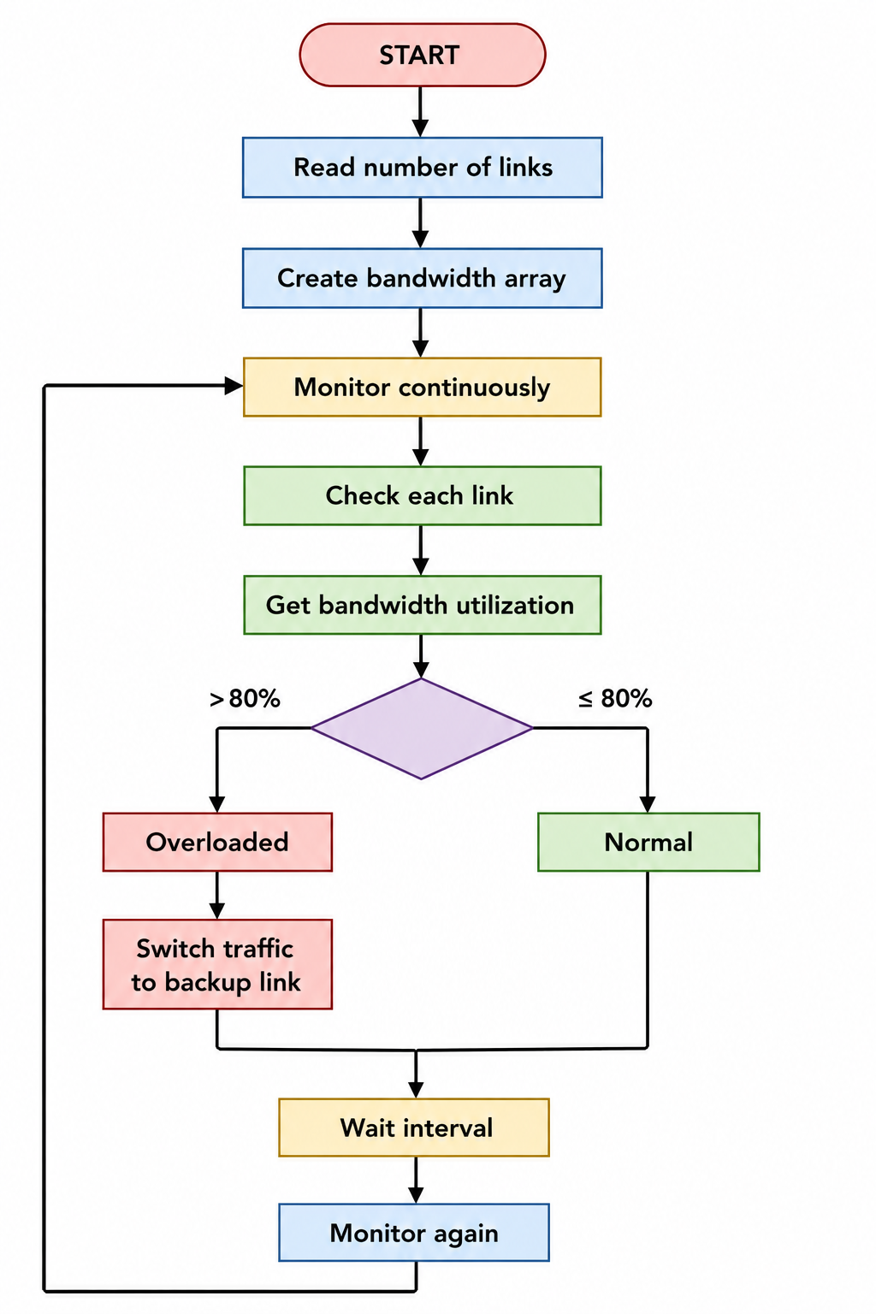

How it improves bandwidth management
- Continuous monitoring: Detects changes in bandwidth usage.
- Early detection: Identifies overloaded links when utilization exceeds 80%.
- Traffic redirection: Suggests moving traffic to a backup link.
- Congestion prevention: Reduces the possibility of excessive traffic on one link.
- Efficient resource usage: Helps distribute network traffic effectively.
The assessment explicitly requires periodic collection, array/list storage, looping through links, an 80% overload condition, and backup-link recommendation.
- A company has six branch offices connected through multiple network links. Each link has different bandwidth, delay, and utilization values, which change throughout the day. The network administrator wants to continuously identify the best communication path between the headquarters and each branch based on overall link quality rather than just the shortest distance. Write a pseudocode algorithm that periodically collects the bandwidth, delay, and utilization of every network link and
stores the values in suitable arrays or lists. Use a loop to repeat the monitoring process at regular intervals. Calculate a link quality score for each path using the collected metrics and select the path with the highest score. Include conditions to detect when a link becomes overloaded or fails, automatically selecting an alternate path and generating an alert for the administrator. Explain how your algorithm improves network reliability, routing efficiency, and fault tolerance while adapting to changing network conditions.
SOLUTION:

Objective
The network contains six branch offices. Each link has:
- Bandwidth
- Delay
- Utilization
These values change during the day. The algorithm must calculate a link quality score, select the highest-scoring path, detect failures/overloads, and switch to an alternate path when required.

Pseudocode

BEGIN

numberOfBranches ← 6

CREATE bandwidth[]
CREATE delay[]
CREATE utilization[]
CREATE linkScore[]
CREATE linkStatus[]

WHILE TRUE DO

DISPLAY "Collecting network information..."

FOR each link FROM 1 TO numberOfBranches DO

INPUT bandwidth[link]
INPUT delay[link]
INPUT utilization[link]
INPUT linkStatus[link]

IF linkStatus[link] = "FAILED" THEN

linkScore[link] ← -1

ELSE IF utilization[link] > 80 THEN

linkScore[link] ← -1

ELSE

linkScore[link] ←
(bandwidth[link] / 100)
+ (100 / delay[link])
+ (100 - utilization[link])

END IF

END FOR

bestScore ← -1
bestPath ← NONE

FOR each link FROM 1 TO numberOfBranches DO

IF linkScore[link] > bestScore THEN

bestScore ← linkScore[link]
bestPath ← link

END IF

END FOR

IF bestPath = NONE THEN

DISPLAY "ALERT: No available path"
DISPLAY "Network administrator attention required"

ELSE

DISPLAY "Best Communication Path: ", bestPath
DISPLAY "Link Quality Score: ", bestScore

END IF

FOR each link FROM 1 TO numberOfBranches DO

IF linkStatus[link] = "FAILED" THEN

DISPLAY "ALERT: Link ", link, " has failed"

ELSE IF utilization[link] > 80 THEN

DISPLAY "ALERT: Link ", link, " is overloaded"

END IF

END FOR

WAIT monitoringInterval

END WHILE

END

Flow of the Algorithm

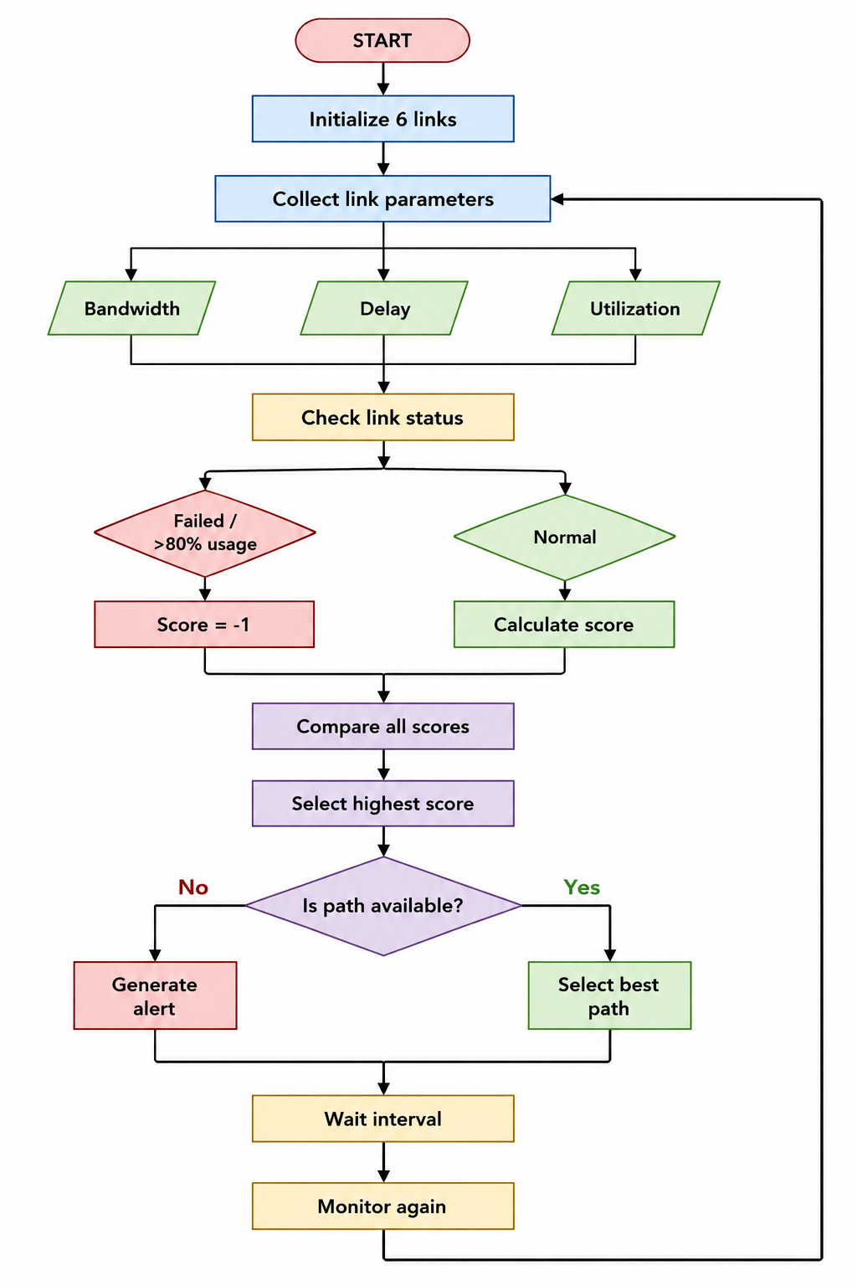

Link Quality Concept
A higher-quality path should generally have:
Metric | Preferred Condition
Bandwidth | Higher
Delay | Lower
Utilization | Lower
Link Status | Active
Overall Score | Higher

Advantages
- Improved reliability – failed links are detected and avoided.
- Better routing efficiency – the path is selected using overall link quality rather than distance alone.
- Fault tolerance – an alternate path can be selected when a link fails or becomes overloaded.
- Adaptive routing – the algorithm repeatedly collects updated values, allowing the selected path to change as network conditions change.
- Congestion avoidance – links with utilization above 80% are avoided.
These are directly aligned with the assessment requirement to improve network reliability, routing efficiency, fault tolerance, and adaptation to changing network conditions.

RUBRICS FOR CALCULATION

Criteria | Weightag e | Level 4 – Exemplary | Level 3 – Proficient | Level 2 – Developing | Level 1 – Beginning
Problem Understanding | 20% | Identifies all inputs, outputs, constraints accurately | Minor missing elements | Partial understandin g | Incorrect interpretatio n
Algorithm Design | 30% | Complete, correct, and logically sound solution | Minor logical gaps | Partially correct logic | Incorrect approach
Use of Control Structures | 20% | Efficient and  appropriate use of loops, conditions, functions/mod ules | Minor  inefficiencie s | Limited or basic usage | Incorrect or missing  constructs
Pseudocode Structure | 10% | Well-structured, clear, consistent format, easy to follow | Mostly clear with minor  issues | Difficult to follow in  parts | Poorly structured and unclear
Completeness | 20% | Handles all cases; optimized | Handles most cases; reasonable | Handles  basic cases only | Incomplete or inefficient

 |  | approach | efficiency

